A Software Report

On

(E-Commerce Store)



Tribhuvan University

Department of computer science and information technology

Submitted By: Submitted To:

Aayush Basnet Laxmi Prasad Yadav

Symbol: 29131/078

**Acknowledgement:**

We extend our heartfelt gratitude to Madan Bhandari Memorial College for providing us with the platform and resources to undertake this project.

I am deeply indebted to our esteemed faculty advisor, Laxmi Prasad Yadav, whose guidance, expertise, and unwavering support were instrumental in shaping our project's direction and success. His dedication to our growth and development has been invaluable, and we are truly grateful for his mentorship.

We also wish to express our appreciation to our fellow students at Madan Bhandari Memorial College for their collaboration, insightful discussions, and constructive feedback, which enriched our project and contributed to its refinement.

Lastly, we commend the commitment and support of each individual. Their dedication, support, and perseverance were vital in overcoming challenges and achieving our goals.

This project stands as a testament to the collective effort and support of everyone involved, and we are deeply appreciative of their contributions.

Aayush Basnet

**Contents:**

1. Introduction

2. Objectives

3. Overview of E-Commerce Store

4. Workflow Diagram

5. Proposed System

6. Requirement Analysis

7. System Design

8. Implementation

9. Coding

10. Future Scope

11. Conclusion

**Introduction:**

An E-Commerce Store is a retail establishment that sells goods & products at significantly valued prices. These goods can include clothing, accessories, household items, furniture, books, toys, and more. An E-Commerce Store specializing in accessories offers a unique shopping experience by providing a wide range of garments at affordable prices. These stores are treasure troves for fashion enthusiasts, bargain hunters, and those looking to express their individual style without breaking the bank.

E-Commerce Stores offer clothing & necessary accessories at the cost of traditional retail stores. Whether you're looking for everyday basics, trendy pieces, or vintage finds, E-Commerce Stores provide an extensive selection to suit various tastes and budgets. By opting for clothing & everyday accessories, shoppers contribute to sustainable fashion practices & everyday easiness in their life. E-Commerce Store shopping aligns with the principles of quality, making it a life-style choice. Overall, E-Commerce Stores specializing in clothing offer more than just affordable fashion—they provide a platform for sustainable shopping, creative expression, and community support, making them popular destinations for quality driven individuals with a conscience.

**Objectives:**

The objectives of an E-Commerce Store specializing in clothing & house-hold accessories can encompass various aspects related to business goals, customer satisfaction, sustainability, and community impact. Here are some key objectives typically associated with such a platform:

1. Provide Affordable Accessories

2. Offer a Diverse Selection

3. Promote Sustainability

4. Quality Driven Product

5. Ensure Customer Satisfaction

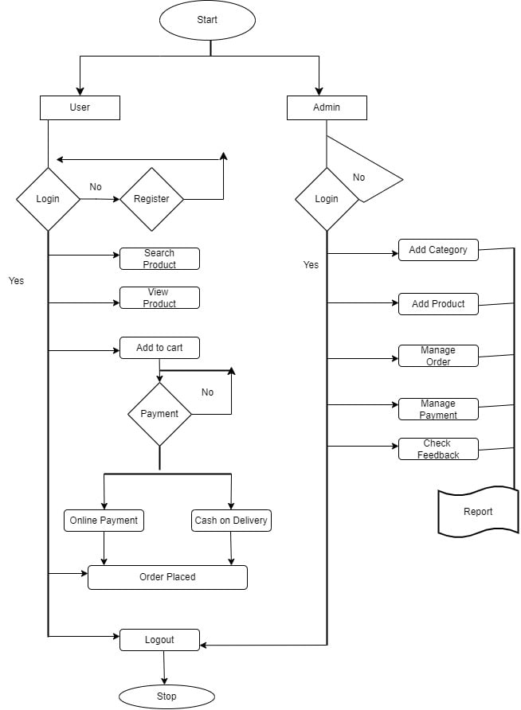

**Workflow Diagram:**

FIG: E-COMMERCE STORE WORKFLOW DIAGRAM

**Proposed system:**

The proposed system for an E-Commerce Store specializing in clothing & house-hold accessories would integrate various features and functionalities to create a seamless and engaging shopping experience for users. Here's an outline of the proposed system:

**User-friendly Interface:** The E-Commerce Store should have an intuitive and visually appealing interface that makes it easy for users to navigate through the website or mobile app. Clear categorization and search functionality should enable users to find desired products quickly.

**User Registration and Profiles:** Users should be able to create accounts/profiles to personalize their shopping experience. Registration enables features such as saved preferences, order history, and notifications about new arrivals or promotions.

**Advanced Search and Filtering:** Advanced search and filtering options allow users to refine their search based on criteria such as size, color, brand, price range, and style. This feature enhances the browsing experience and helps users find relevant items more efficiently.

**Secure Payment Gateway:** Integration with a secure payment gateway ensures that users can make purchases safely and conveniently. Accepted payment methods may include credit/debit cards, digital wallets, and other payment options.

**Responsive Design:** The E-Commerce Store should be optimized for various devices, including desktops, laptops, smartphones, and tablets. Responsive design ensures a consistent and user-friendly experience across different screen sizes and resolutions.

**Customer Support:** A dedicated customer support system, including FAQs, help articles, and contact channels (e.g., email, live chat), should be available to assist users with inquiries, issues, or feedback.

**Shopping Cart and Wish-List:** Users should be able to add items to their shopping cart for future purchase or create a Wish-List to save items for later. The system should retain these selections across user sessions to facilitate seamless shopping.

**Actors:**

In an E-Commerce Store, there are several main actors or stakeholders involved in the system. Here are the main actors typically involved:

1. Customers/Shoppers

2. Sellers

3. Payment Gateway Providers

4. Technology Providers

**Requirement Analysis:**

**Functional and Non-functional requirement:**

|  |  |
| --- | --- |
| **Functional Requirements** | **Requirements** |
| User Registration | Users should be able to create accounts and profiles |
| Browse and Search | Users should be able to browse and search for clothing items |
| Product Listings | Sellers should be able to create listings for clothing items |
| Shopping Cart | Users should be able to add items to a shopping cart |
| Order Management | Users should be able to track orders and view order history |
| Payment Integration | Integration with payment gateways for secure transactions |

|  |  |
| --- | --- |
| **Non-functional Requirements** | **Requirements** |
| Performance | Fast loading times and responsive interface |
| Scalability | Ability to handle increasing numbers of users and listings |
| Security | Encryption of sensitive data, secure payment processing |
| Compatibility | Compatibility with various devices and browsers |
| Performance | Response time for searches and page loads |
| Usability | Intuitive user interface, easy navigation |

**Feasibility Analysis:**

A feasibility study for an E-Commerce Store involves a systematic assessment of various factors to determine the viability and potential success of the business concept. By conducting a comprehensive feasibility analysis, stakeholders can assess the viability of launching an E-Commerce Store and identify opportunities to optimize business performance and mitigate risks.

**1)Market Feasibility:**

**> Demand:** Evaluate the demand for clothing & other accessories, considering factors such as increasing interest in sustainable fashion, budget-conscious consumers, and the popularity of shopping.

**> Competition:** Analyze existing E-Commerce Stores, traditional retailers, and fashion marketplaces to identify market gaps and potential niches.

**> Trends:** Research current fashion trends, consumer preferences, and purchasing behaviors.

**2)Technical Feasibility:**

**> E-commerce Platform:** Assess the technical requirements for building and maintaining an e-commerce website or mobile app, including hosting, security, payment processing, and inventory management systems.

**> Website Development:** Evaluate the feasibility of developing a user-friendly interface, search functionality, shopping cart, and checkout process that meets customer expectations.

**> Scalability:** Consider the scalability of the technology infrastructure to accommodate increasing website traffic, user registrations, and product listings over time.

**3)Financial Feasibility:**

**> Startup Costs:** Estimate the initial investment required for website development, inventory acquisition, marketing, and operational expenses.

**> Profitability:** Calculate projected revenues, expenses, and profit margins to determine the feasibility of achieving profitability within a reasonable timeframe.

**4)Operational Feasibility:**

**> Inventory Sourcing:** Assess the feasibility of sourcing items from various suppliers, including individuals, Stores, wholesalers, and consignment shops.

**> Order Fulfillment:** Evaluate the feasibility of managing inventory, processing orders, packaging, and shipping logistics efficiently and cost-effectively.

**> Customer Service:** Determine the feasibility of providing responsive customer support, handling returns and exchanges, and resolving inquiries or issues in a timely manner.

**5)Legal and Regulatory Feasibility:**

**>Business Licensing:** Research the legal requirements for operating online business, including obtaining business licenses, permits, and tax registrations.

**>Data Privacy:** Ensure compliance with data protection regulations, such as GDPR or CCPA, by implementing privacy policies, data security measures, and consent mechanisms.

**> Intellectual Property:** Assess the feasibility of trademarking the brand name, logo, or other intellectual property assets to protect against infringement.

**6)Environmental and Social Feasibility:**

**>Sustainability Practices:** Evaluate the feasibility of promoting sustainable fashion practices, reducing textile waste, and supporting environmental initiatives through the E-Commerce Store.

**>Community Engagement:** Assess the feasibility of fostering a sense of community among customers, sellers, and stakeholders through social media, forums, and collaborative initiatives.

**System Design:**

**Use case models:**

A use case model provides a comprehensive overview of how users interact with the E-Commerce Store system to achieve specific goals or tasks. It identifies different user roles, their respective responsibilities, and the actions they can perform within the system.

**1) Administrator use case model:**

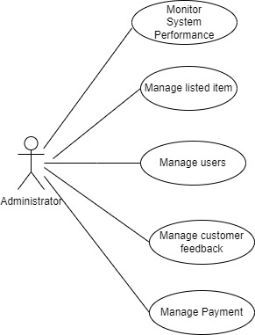

The administration use case model of E-Commerce Store involves detailing the interactions and functionalities available to administrators or staff members who manage the platform. These administrators typically oversee various aspects of the system, like manage payment, customer feedback, users, listed items, system performance etc.

**2) Customer use case model:**

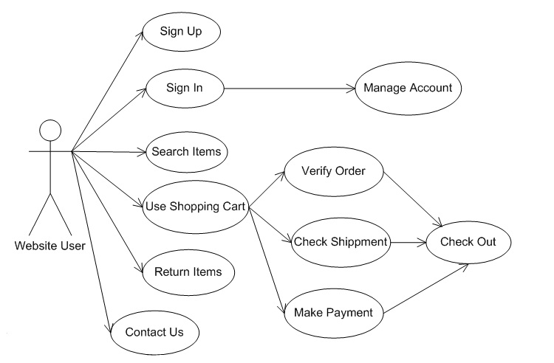

These customer use cases collectively provide a comprehensive overview of the interactions and functionalities available to customers when using the E-Commerce Store platform.

**3) Searching products use case model:**

The "Search for Clothing" use case allows customers to search for specific clothing items based on various criteria such as category, size, color, brand, or keyword. Customers can utilize the search functionality provided by the E-Commerce Store platform to find items that match their preferences and meet their needs.

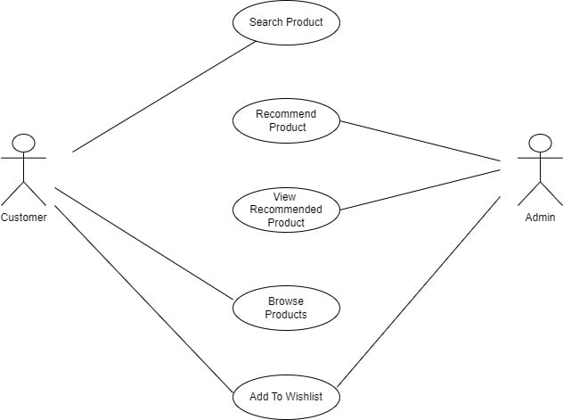

**4) Add to cart use case model:**

The "Add to Cart" use case allows customers to add selected clothing items to their shopping cart for eventual purchase. This functionality enables customers to compile a collection of items they wish to buy and proceed to checkout when ready.

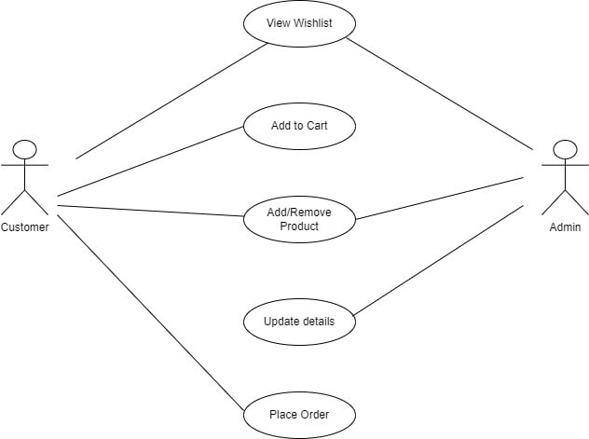

**5) Payment Use case model:**

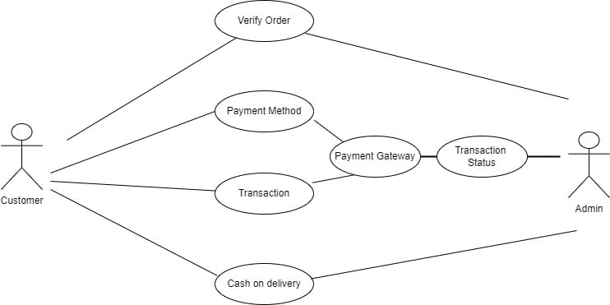

The payment process allows customers to securely complete their purchases by providing payment information and authorizing the transaction.

**Activity Diagram:**

An activity diagram for an E-Commerce Store system illustrates the workflow or sequence of activities involved in various processes within the system.

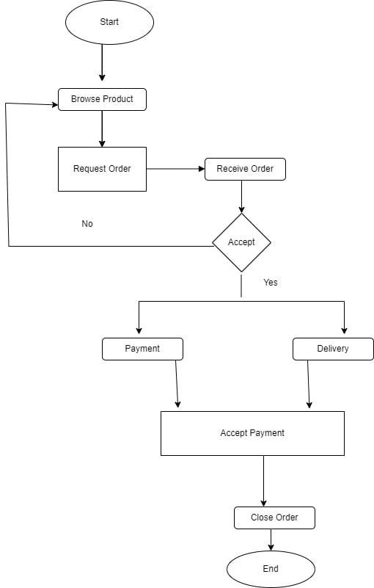

**Sequence Diagram:**

A sequence diagram for an E-Commerce Store system illustrates the interactions between different components or objects in the system over time.

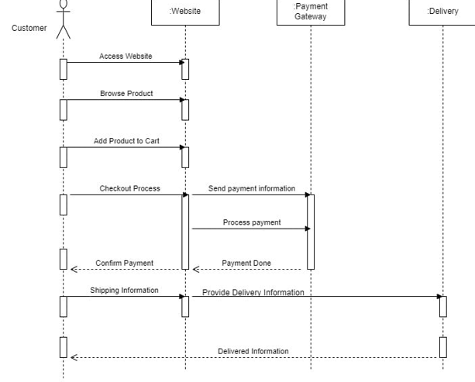

**Class Diagram:**

A class diagram for an E-Commerce Store specializing in clothing would depict the various classes and their relationships within the system.

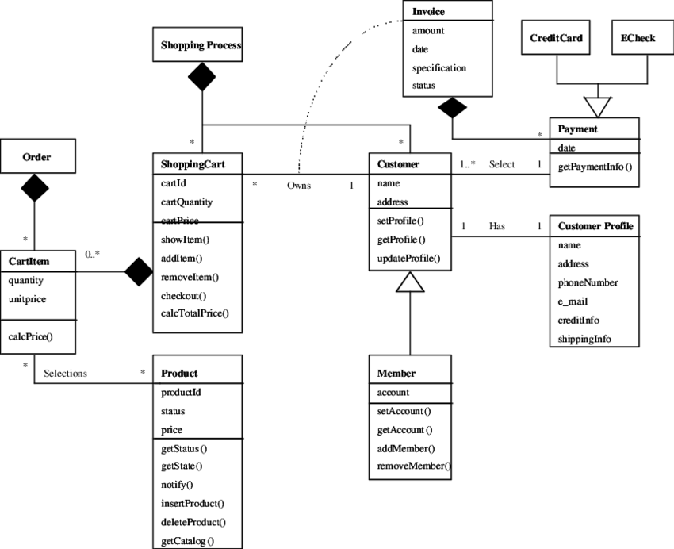

**Component Diagram:**

A component diagram for an E-Commerce Store specializing in clothing illustrates the high-level structure of the system and its components, including their interactions and dependencies.

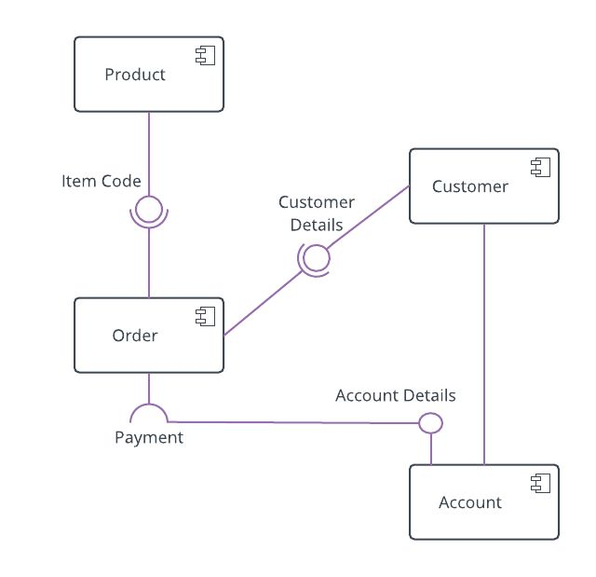

**Deployment Diagram:**

A deployment diagram for an E-Commerce Store system illustrates the physical deployment of software components and their relationships on hardware nodes.

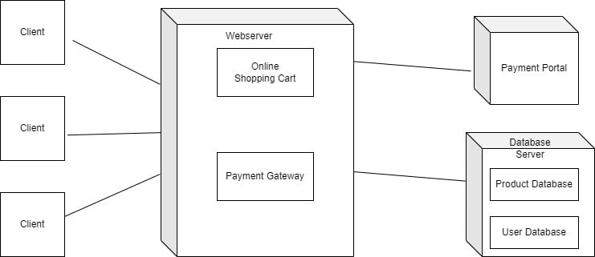

**Implementation:**

Home Page:

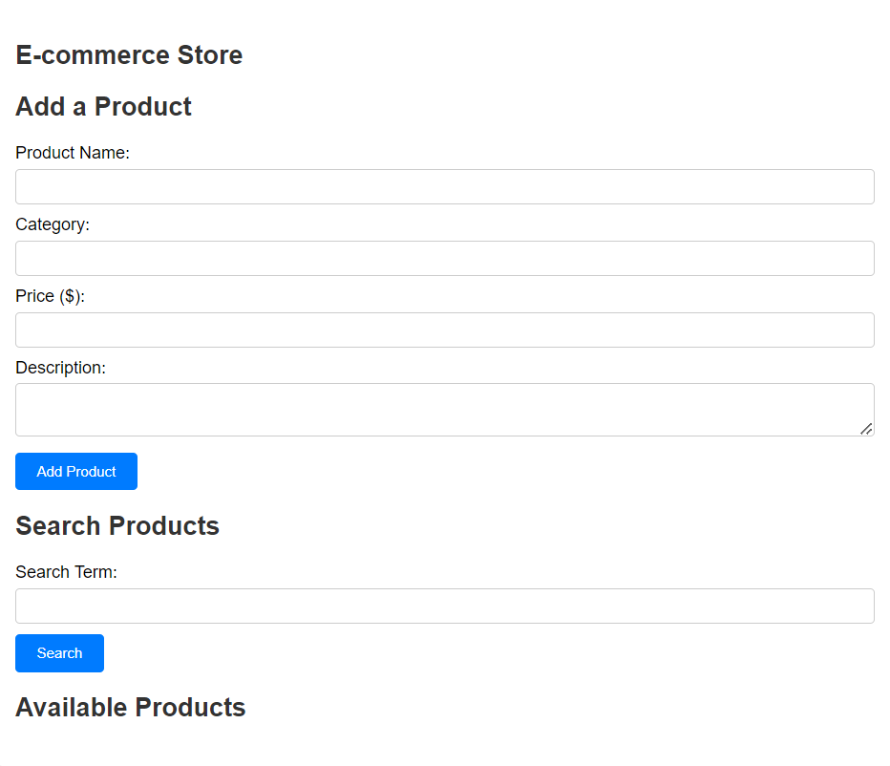

1. Available Products:

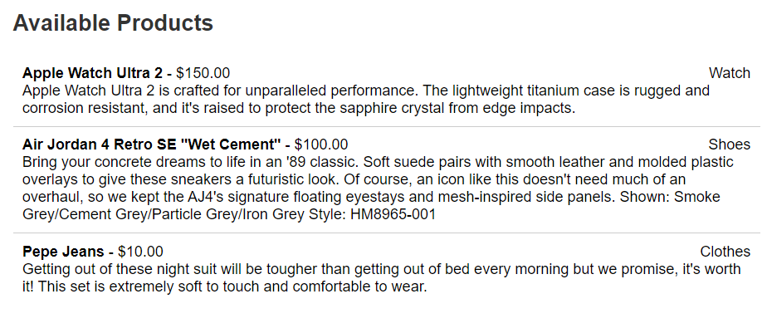

1. Search Product:

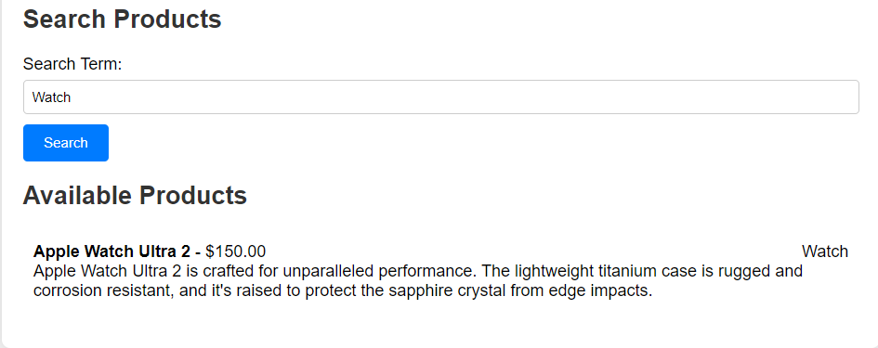

**CODE:**

HTML:

**-index.html**

<!DOCTYPE html>

<html lang="en">

<head>

<meta charset="UTF-8">

<meta name="viewport" content="width=device-width, initial-scale=1.0">

<title>Ecommerce Store</title>

<link rel="stylesheet" href="style.css">

</head>

<body>

<div class="container">

<h2>E-commerce Store</h2>

<!-- Form to add new product -->

<form id="addProductForm">

<h2>Add a Product</h2>

<label for="productName">Product Name:</label>

<input type="text" id="productName" required><br>

<label for="categoryName">Category:</label>

<input type="text" id="categoryName" required><br>

<label for="productPrice">Price ($):</label>

<input type="number" id="productPrice" min="0" step="0.01" required>

<label for="productDescription">Description:</label>

<textarea id="productDescription" required></textarea><br>

<button type="submit">Add Product</button>

</form>

<!-- Search form -->

<form id="searchProductForm">

<h2>Search Products</h2>

<label for="searchTerm">Search Term:</label>

<input type="text" id="searchTerm">

<button type="submit">Search</button>

</form>

<!-- Display area for products -->

<div id="productList">

<h2>Available Products</h2>

<ul id="products"></ul>

</div>

</div>

<script src="script.js"></script>

</body>

</html>

**style.css**

body {

font-family: Arial, sans-serif;

background-color: #f0f0f0;

margin: 0;

padding: 0;

}

.container {

max-width: 800px;

margin: 20px auto;

background-color: #fff;

padding: 20px;

border-radius: 8px;

box-shadow: 0 0 10px rgba(0, 0, 0, 0.1);

}

h1, h2 {

color: #333;

}

form {

margin-bottom: 20px;

}

label {

display: block;

margin-bottom: 5px;

}

input[type="text"],

input[type="number"],

textarea {

width: 100%;

padding: 8px;

margin-bottom: 10px;

border: 1px solid #ccc;

border-radius: 4px;

box-sizing: border-box;

}

button {

padding: 10px 20px;

background-color: #007bff;

color: #fff;

border: none;

cursor: pointer;

border-radius: 4px;

}

button:hover {

background-color: #0056b3;

}

#products {

list-style-type: none;

padding: 0;

}

#products li {

padding: 10px;

border-bottom: 1px solid #ccc;

}

#products li:last-child {

border-bottom: none;

}

**script.js**

// Array to store products

let products = [];

// DOM elements

const productList = document.getElementById('products');

const addProductForm = document.getElementById('addProductForm');

const productNameInput = document.getElementById('productName');

const categoryNameInput = document.getElementById('categoryName');

const productPriceInput = document.getElementById('productPrice');

const productDescriptionInput = document.getElementById('productDescription');

const searchProductForm = document.getElementById('searchProductForm');

const searchTermInput = document.getElementById('searchTerm');

// Function to add a product

function addProduct(event) {

event.preventDefault();

const name = productNameInput.value.trim();

const category = categoryNameInput.value.trim();

const price = parseFloat(productPriceInput.value);

const description = productDescriptionInput.value.trim();

if (name === '' || isNaN(price) || description === '') {

alert('Please fill in all fields.');

return;

}

const product = { name, category, price, description };

products.push(product);

// Clear form inputs

productNameInput.value = '';

categoryNameInput.value = '';

productPriceInput.value = '';

productDescriptionInput.value = '';

displayProducts();

}

// Function to display all products

function displayProducts() {

productList.innerHTML = '';

products.forEach((product, index) => {

const li = document.createElement('li');

li.innerHTML = `<strong>${product.name}</strong> - $${product.price.toFixed(2)}<span style="float: right;">${product.category}</span><br>${product.description}`;

productList.appendChild(li);

});

}

// Function to search for products

function searchProducts(event) {

event.preventDefault();

const searchTerm = searchTermInput.value.trim().toLowerCase();

if (searchTerm === '') {

displayProducts();

return;

}

const filteredProducts = products.filter(product =>

product.name.toLowerCase().includes(searchTerm) ||

product.description.toLowerCase().includes(searchTerm) ||

product.category.toLowerCase().includes(searchTerm)

);

productList.innerHTML = '';

if (filteredProducts.length > 0) {

filteredProducts.forEach(product => {

const li = document.createElement('li');

li.innerHTML = `<strong>${product.name}</strong> - $${product.price.toFixed(2)}<span style="float: right;">${product.category}</span><br>${product.description}`;

productList.appendChild(li);

});

} else {

const li = document.createElement('li');

li.textContent = 'No products found.';

productList.appendChild(li);

}

}

// Event listeners

addProductForm.addEventListener('submit', addProduct);

searchProductForm.addEventListener('submit', searchProducts);

**FUTURE SCOPE:**

The concept of a E-Commerce Store in software engineering is intriguing and can be explored through multiple facets, including reuse, sustainability, cost-effectiveness, and community-driven development. Here are some potential future scopes and opportunities for such an initiative:

**1. Software Reuse and Recycling**

* Component Libraries: Development and maintenance of extensive libraries of reusable software components, modules, and services.
* Legacy Software: Refurbishing and repurposing older software systems for modern use cases, saving costs and resources.
* Code Repositories: Establishing repositories where developers can share, find, and reuse code snippets, frameworks, and entire applications.

**2. Open Source and Community Collaboration**

* Open Source Projects: Encouraging the development and contribution to open-source projects, providing free or low-cost solutions to common problems.
* Community Support: Building a community-driven support system where developers can help each other in adapting and modifying reused software.

**3. Sustainability and Green Computing**

* Energy Efficiency: Promoting the reuse of efficient algorithms and software practices to reduce the carbon footprint of software development.
* Eco-friendly Practices: Encouraging practices that extend the life of existing software and hardware, reducing e-waste.

**4. Cost-Effective Solutions**

* Affordable Software: Providing low-cost or free software solutions for startups, non-profits, and educational institutions.
* Freelance and Gig Economy: Creating opportunities for freelance developers to offer their refurbished or custom-developed software at E-Commerce Store-like prices.

**5. Education and Training**

* Learning Platforms: Developing platforms where aspiring developers can learn from existing projects, understanding how to repurpose and adapt code.
* Workshops and Seminars: Hosting events that focus on teaching the skills necessary for software recycling and reuse.

**CONCLUSION:**

The E-Commerce Store project has been a remarkable journey, transforming a concept into a fully functional platform that aligns with modern trends of sustainability, affordability, and community engagement. Our mission to create a digital marketplace for pre-loved items has not only been realized but has also exceeded initial expectations in several key areas.

**Key Achievements**

1. Sustainable Impact: The project successfully promoted better lifestyles by focusing on high quality products, thus contributing to better living standard.
2. Community Building: We have built a vibrant community of users who actively engage in buying, selling, fostering a culture of sharing and collaboration.
3. Affordability and Accessibility: By offering a wide range of affordable products, we have made quality goods accessible to a broader audience, supporting financial inclusivity.
4. User Experience: The platform's user-friendly interface and robust functionalities, including secure payment systems, efficient search capabilities, and reliable delivery options, have enhanced the overall user experience.

**Challenges Faced**

1. Initial Adoption: Encouraging users to adopt a new platform required significant marketing efforts and educational campaigns.
2. Quality Control: Maintaining the quality and authenticity of items listed on the platform posed an ongoing challenge, necessitating rigorous vetting and user feedback systems.
3. Technical Hurdles: Developing and maintaining a scalable, secure, and efficient platform required continuous technical innovation and problem-solving.
4. Competition: Navigating a competitive market with established players demanded strategic planning and differentiation in service offerings.

Thank you to all individuals for their unwavering support and contribution to this meaningful journey. Together, we have created not just a marketplace, but a movement towards a more sustainable and connected world.